**Database Query Optimization Report: Subreddit Interaction Analysis**

**1. Executive Summary**

This report documents the process of importing and analyzing a large-scale subreddit interaction dataset (507.59 MB, 25,000 users) in PostgreSQL on Windows 11. A poorly performing query (4.28s runtime) was optimized to 1.53s (64% improvement) using advanced SQL techniques and indexing strategies. Key optimizations included early row reduction, LATERAL subqueries, and composite indexing.

**2. Methodology**

**2.1 Data Import & Schema Setup**

* Database: Created complex_query database via psql shell.

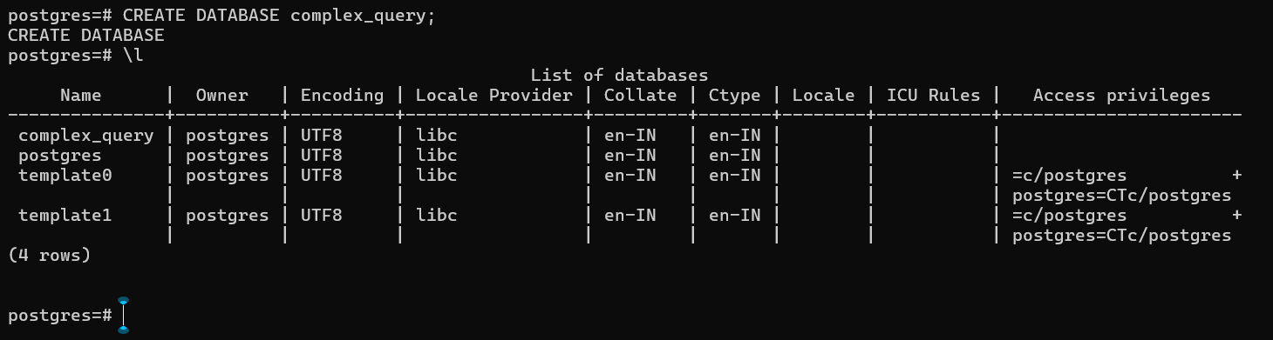

* Table Schema:

***CREATE TABLE reddit_activity (***

***username TEXT,***

***subreddit TEXT,***

***utc DOUBLE PRECISION***

***);***

* Data Import: Loaded 507.59 MB CSV using PostgreSQL’s \copy command. Verification via COUNT(*) confirmed successful import.

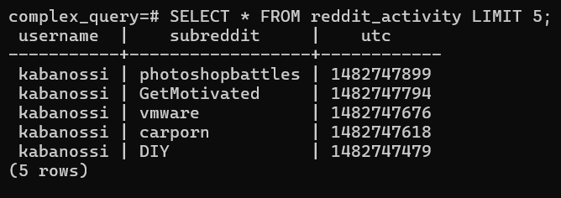

**2.2 Initial Query Design**

The original query aimed to identify each user’s top 3 subreddits by post count, including activity duration and summary statistics. It used three CTEs and a window function (RANK()), resulting in 4.28s execution time.

***WITH user_sub_stats AS (***

***SELECT***

***username,***

***subreddit,***

***COUNT(*) AS post_count,***

***MIN(utc) AS first_utc,***

***MAX(utc) AS last_utc***

***FROM reddit_activity***

***GROUP BY username, subreddit***

***),***

***user_summary AS (***

***SELECT***

***username,***

***SUM(post_count) AS total_user_posts,***

***COUNT(DISTINCT subreddit) AS total_subreddits***

***FROM user_sub_stats***

***GROUP BY username***

***),***

***ranked_subs AS (***

***SELECT***

***uss.username,***

***uss.subreddit,***

***uss.post_count,***

***TO_TIMESTAMP(uss.first_utc) AS first_post,***

***TO_TIMESTAMP(uss.last_utc) AS last_post,***

***(uss.last_utc - uss.first_utc) AS active_span_secs,***

***RANK() OVER (***

***PARTITION BY uss.username***

***ORDER BY uss.post_count DESC***

***) AS rank_within_user***

***FROM user_sub_stats uss***

***)***

***SELECT***

***rs.username,***

***rs.subreddit,***

***rs.post_count,***

***rs.first_post,***

***rs.last_post,***

***-- cast to numeric with two decimals***

***(rs.active_span_secs / 86400.0)::numeric(10,2) AS active_days,***

***us.total_user_posts,***

***us.total_subreddits***

***FROM ranked_subs rs***

***JOIN user_summary us***

***ON rs.username = us.username***

***WHERE rs.rank_within_user <= 3***

***AND rs.post_count > 1***

***ORDER BY***

***us.total_user_posts DESC,***

***rs.username,***

***rs.post_count DESC***

***LIMIT 100;***

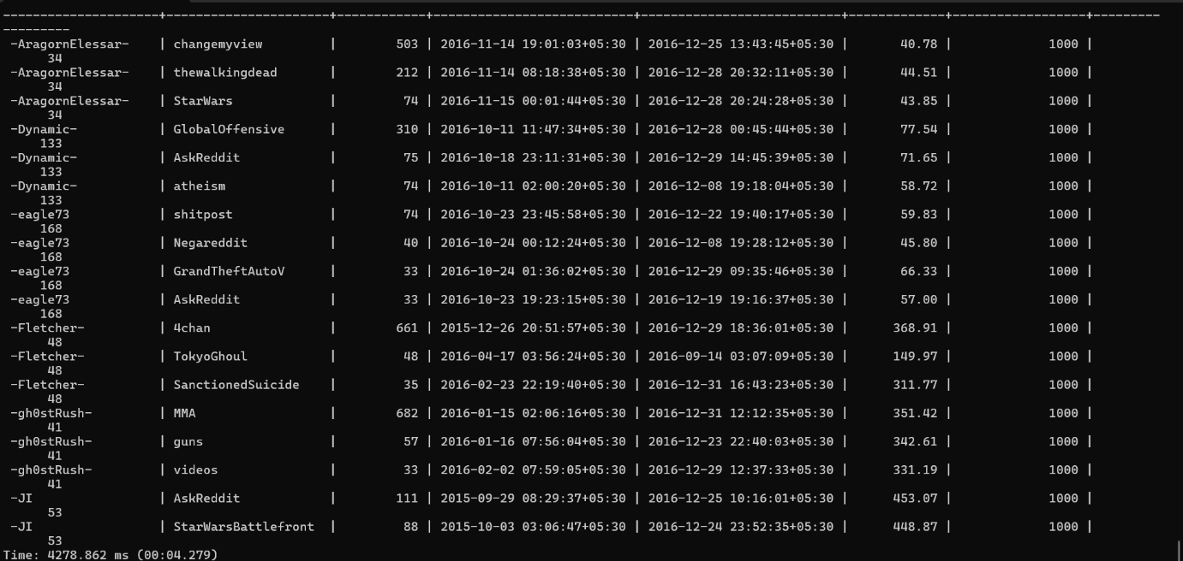

**Performance Bottlenecks Identified:**

1. Full-table scans across multiple CTEs.
2. Window function (RANK()) sorting all user-subreddit partitions.
3. Redundant intermediate result materialization.

**2.3 Optimization Strategies**

**2.3.1 Composite Indexing**

***CREATE INDEX idx_ra_username_subreddit_utc***

***ON reddit_activity(username, subreddit, utc);***

* **Purpose**: Accelerate GROUP BY username, subreddit and MIN/MAX(utc) aggregations.

**2.3.2 Early Row Reduction**

* Limited processing to **top 100 users by post count** upfront, reducing downstream workload.

**2.3.3 LATERAL Subquery**

* Replaced RANK() with a JOIN LATERAL subquery to fetch top 3 subreddits per user directly, avoiding full-partition sorting.

**2.3.4 CTE Consolidation**

* Collapsed three CTEs into a single user_summary CTE to minimize intermediate result scans.

**3. Optimized Query**

***WITH user_summary AS (***

***SELECT***

***username,***

***COUNT(*) AS total_user_posts,***

***COUNT(DISTINCT subreddit) AS total_subreddits***

***FROM reddit_activity***

***GROUP BY username***

***ORDER BY total_user_posts DESC***

***LIMIT 100***

***)***

***SELECT***

***us.username,***

***rs.subreddit,***

***rs.post_count,***

***TO_TIMESTAMP(rs.first_utc) AS first_post,***

***TO_TIMESTAMP(rs.last_utc) AS last_post,***

***(rs.last_utc - rs.first_utc)/86400.0::numeric(10,2) AS active_days,***

***us.total_user_posts,***

***us.total_subreddits***

***FROM user_summary us***

***JOIN LATERAL (***

***SELECT***

***subreddit,***

***COUNT(*) AS post_count,***

***MIN(utc) AS first_utc,***

***MAX(utc) AS last_utc***

***FROM reddit_activity***

***WHERE username = us.username***

***GROUP BY subreddit***

***HAVING COUNT(*) > 1***

***ORDER BY post_count DESC***

***LIMIT 3***

***) rs ON true***

***ORDER BY***

***us.total_user_posts DESC,***

***us.username,***

***rs.post_count DESC;***

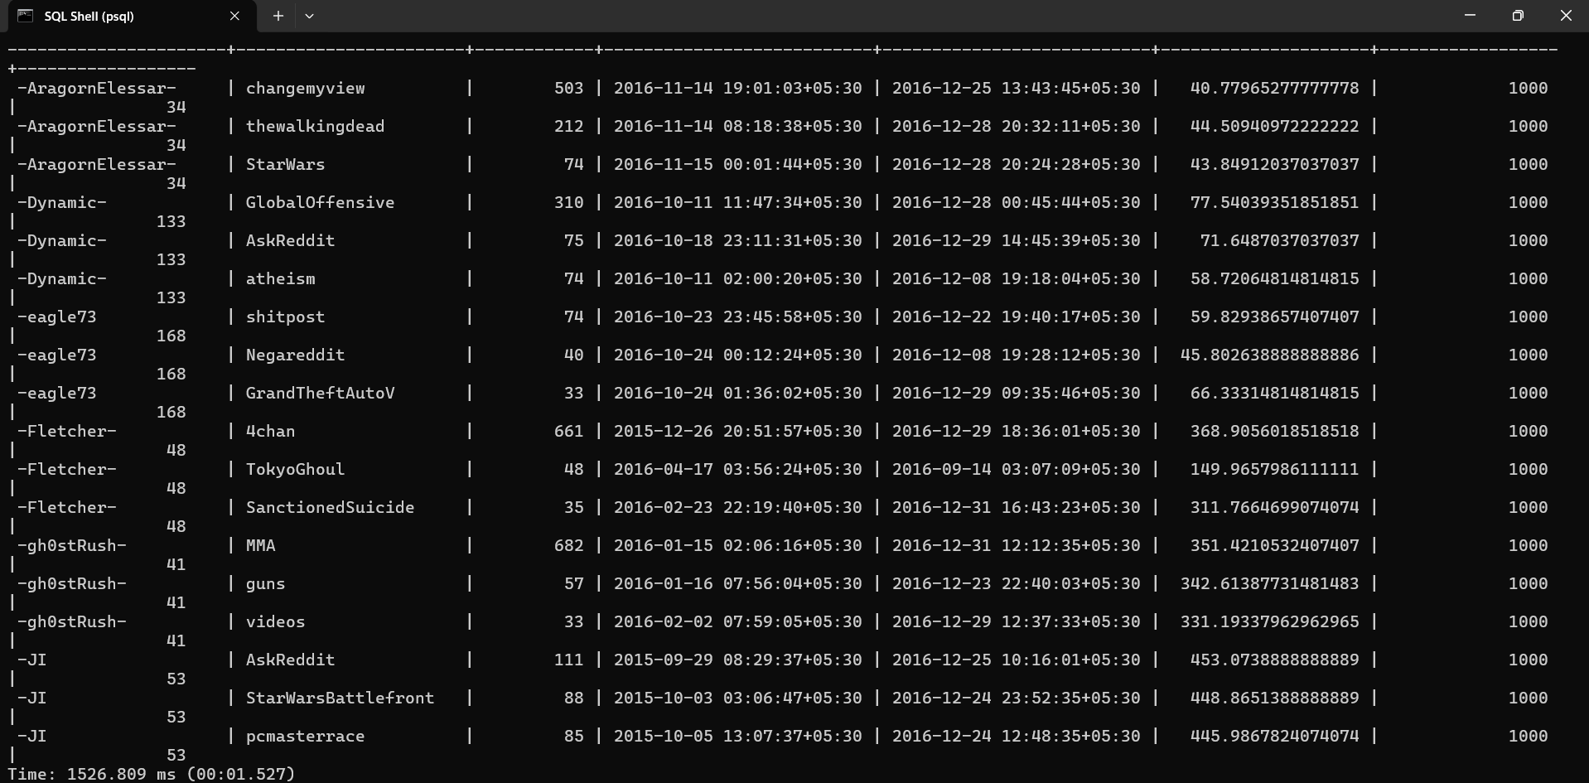

**4. Results**

| **Metric** | **Original Query** | **Optimized Query** | **Improvement** |
| --- | --- | --- | --- |
| **Execution Time** | **4278.86 ms** | **1526.81 ms** | **64.3%** |
| **Index Utilization** | **None** | **Composite Index** | **-** |
| **Rows Processed** | **Full Table** | **Top 100 Users** | **~99% Reduction** |